**Bug on Page ‘my.bonify.de’:**

**Issues 9:**

On '**https://my.bonify.de/login?next=/**' Page, there is no option to go back to Home Page.

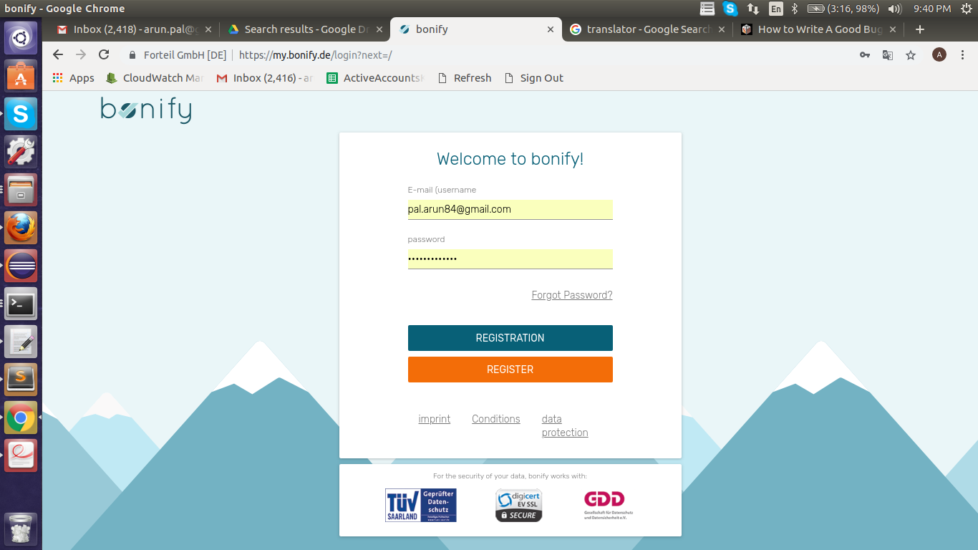

**Steps To Reproduce:**

1: Start Chrome Browser with url '**https://my.bonify.de/login?next=/’.**

2: Observe that is is no way to go back to Home page.

Note- ‘Bonify Logo’ at top left of the Page should be clickable to redirect to Home Page.

**Expected Result:** On Login page there should be option to go back to Home Page or just clicking on ‘bonify’ logo it should go back to Home Page.

**Actual Result:** There is no option to go back to Home page.

**Browser:** Chrome (Version 70)

**OS:** Ubuntu (16)

**Priority:** P1

**Assign To :** Developer.